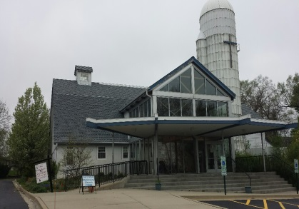  **Doctor’s Note for Sick Child Policy**

Here at The Big Barn Preschool your child’s health and wellbeing are important to us. Therefore it is our policy that if your child is ill and needs to see a doctor He/she ***may*** receive free days for their illness. **Depending on the illness Doctors note may be refused.** This is up to the Directors discretion. These steps must be followed:

* Child must go to a doctor
* Doctor must determine the illness is contagious
* Doctor must label the illness
* Doctor must say when the child may return to school
* Note must be signed and dated

## *If all of these items are not satisfied the note will not be accepted. This does not qualify for colds, flu like symptoms, stomach flus, allergies, or fevers without other symptoms.*

**Children with the following conditions do not have to be excluded from childcare, if they feel well enough to participate in regular activities:**

* Canker Sores
* Colds or coughs, without fever or other signs of illness
* Cold Sores
* Croup
* Disease spread by mosquitos: Malaria, West Nile Virus
* Diseases spread by ticks: Babesiosis, Ehrlichiosis, Lyme Disease, Rocky Mountain Spotted Fever, Tularemia
* Ear Infection
* Fifth Disease
* HIV Infection
* MRSA, if child is only a carrier
* Pinworms
* Rash without fever or behavior change
* Roseola, once the fever is gone
* Thrush
* Urinary Tract Infection

Parent Signature __________________________________________ Date ________________

Parent Signature __________________________________________ Date ________________

Director Signature __________________________________________ Date _______________